ROOTING IN FOREIGN SOIL: AN ANALYSIS OF HYBRIDITY AND DIASPORA IN FAMILY REPRESENTATION IN MINARI

Allysa Mutiara Sani¹ & Yusrina Dinar Prihatika^{2*}
¹Universitas Ahmad Dahlan
²Universitas Ahmad Dahlan

Corresponding Author: Yusrina Dinar Prihatika, E-mail: yusrina@enlitera.uad.ac.id
ARTICLE INFO | ABSTRACT
Received: 30-07-2025  Revised: 09-09-2025  Accepted: 09-10-2025  Published: 15-10-2025  Volume: 9  Issue: 3  DOI: https://doi.org/10.33019/lire.v9i3.506 | This study investigates how Lee Isaac Chung’s film Minari (2020) represents cultural hybridity and diasporic identity negotiation within a Korean-American immigrant family in Arkansas. Using hybridity and diaspora theoretical frameworks, this research addresses how Yi family balances preservation of Korean cultural heritage with adaptation to American societal norms. Through semiotic and narrative analysis, the study finds that Minari portrays hybrid identity formation as a dynamic and intergenerational process characterized by both cultural retention and adaptation. It reveals familial conflicts and solidarities that highlight differing aspirations-such as Jacob’s pursuit of the American Drea, balanced against the family’s Korean heritage, and Monica’s emphasis on familial cohesion. The diaspora community emerges as a crucial space for articulating multifaceted identities and supporting resilience amid economic and social challenges. These findings illustrate how Minari critically engages with immigrant experiences, offering nuanced insight into identity negotiation beyond assimilation paradigm.
KEYWORDS
Cultural Hybridity, Korean-American Diaspora, Multiculturalism, Homi K. Babha

1.INTRODUCTION
The increasing globalization and enhanced human mobility of recent decades have shaped new social and cultural landscapes, giving rise to diverse diaspora communities. Diaspora, defined as the dispersal of people from homeland, triggers complex processes of identity renegotiation and cultural hybridity. Immigrants must continuously adapt to their host societies while striving to preserve their cultural roots creating layered and multifaced identities (Ortega, 2020).
In this context, Minari (2020), directed by Lee Isaac Chung, offers a poignant portrayal of the Korean- American immigrant experience in the United States during the 1980s. The film follows the Yi family as they relocate from California to Arkansas, confronting not only economic challenges but also cultural tensions. It vividly depicts how immigrant families balance maintaining traditional Korean values-such as language, customs, and collective family priorities-with the pressures of assimilation into American society.
This duality reflects broader patterns observed in immigrant communities, where cultural exchange and acculturation result in hybrid identities shaped by both the preservation of the culture of origin and the absorption of local influences (Dogutas, 2024). Specifically, the film explores intergenerational dynamics, showing how first-generation parents and their children negotiate identity differently within the diaspora space.

Grounded in theories hybridity and diaspora, this study analyses Minari’s representation of identity negotiations and cultural conflict in Minari, focusing on how the Yi family’s experiences illustrate the complexities of living between two worlds. The study highlights the importance of diaspora communities as space for solidarity, cultural exchange, and identity articulation.
By analysing these themes through semiotic and narrative approach, this research aims to deepen understanding of the struggles of immigrant families regarding cultural preservation, economic survival, and social belonging. This study contributes to cultural studies by showing how popular media such as Minari can serve as a meaningful space for exploring hybrid identities and multicultural realities in contemporary society.

2. LITERATURE REVIEW
The concept of cultural hybridity and diaspora provide an essential framework for understanding the identity negotiations faced by immigrant families in multicultural contexts. The theory of cultural hybridity, introduced by Homi K. Babha (1994), describes a “third space” where cultural identities is neither entirely authentic nor entirely assimilated, but rather dynamically negotiated through interaction and resistance. This “third space” facilitates the formation of flexible hybrid identities that transcend binary oppositions between the culture of origin and host cultures (Rohman, 2025). Supporting this, Ojuola (2024) highlights that the “third space” acts as a boundary zone facilitating cultural negotiations and new identity formations, while Michael (2025) emphasizes hybridity’s potential for ambiguity and innovative cultural expression. In immigrant contexts, hybridity manifest as individuals blend traditional values with local cultural practices, for examples through bilingualism or selective cultural adaptation.
Complementing hybridity theory, diaspora scholarship focuses on the emotional and transnational dimensions of migrant identities. Baubock and Faist (2010) conceptualize diaspora through transnationalism-the cross-border connections that immigrants maintain between their countries of origin and settlement. Michael (2025) further notes that scholars like Stuart Hall and James Clifford argue diasporic identities emerge from memory, loss, longing, as well as cultural reinvention within diaspora communities. These communities not only preserve cultural heritage but also offer spaces for identity negotiation amid assimilation pressures and marginalization.
Several studies have applied these frameworks to Asian immigrant experiences in media. For instance, Aziza (2021) examines Minari’s portrayal of generational differences in identity, showing the first generation maintaining Korean traditions while the second generation embodies hybrid Korean-American identities through language and cultural practices. Similarly, Solihin, Waluyo, and Bahriyah (2023) analyse dialog and symbolism in Minari, highlighting intergenerational tensions and the Minari plant as a metaphor for resilience.
Despite this valuable insights, existing research on Minari largely focuses on isolated aspects such as single generation perspectives or general immigrant experiences. Few studies adopt an integrated approach that considers intergenerational interactions within hybridity processes or employ a transnational lens emphasizing the simultaneous connection to multiple cultural spaces. Additionally, the symbolic elements in the film, like the Minari plant, have not been thoroughly explored as representation of cultural hybridity and diaspora resilience.
This study seeks to fill these gaps by applying Babha’s hybridity theory alongside Baubock and Faist transnational diaspora framework to holistically analyse the Yi Family’s identities negotiation and cultural adaptation strategies in Minari. Through this integrative approach, the research aims to uncover how familial and communal dynamics interweave in the formation of hybrid immigrant identities within the diaspora context.

3. METHODOLOGY
The research methodology employs a qualitative approach focused on film text analysis of Minari, chosen for its ability to uncover deep meanings in the complexity of cultural representations, identities, and diasporic experiences within the film. The primary goals of this study are to analyze the representation of cultural hybridity and diasporic experiences in the Korean-American immigrant Yi family, examine how the family handles identity negotiation between their Korean culture of origin and their new American culture, and specifically analyze this negotiation process using key concepts like liminality and cultural ambivalence that underline the complexity of hybridity. The research also aims to reveal the meaning of identity and the struggles of Korean immigrant families using the frameworks of Hybridity (Homi K. Bhabha) and Diaspora theory. The overall analytical framework examines the representation of Korean and American culture, the process of identity negotiation through intergenerational conflict and adaptation, and the diaspora experience, which includes longing for the homeland, the formation of diaspora communities, and the pressure of assimilation.
The data analysis techniques utilized are a combination of semiotic analysis and narrative analysis. This dual approach is justified because hybridity is formed through the dynamic exchange and reinterpretation of cultural signs and symbols, and semiotic analysis is essential for identifying and interpreting the denotative and connotative meanings of these signs. According to Barthes (1972), a sign has two levels of meaning: denotation and connotation. Denotation refers to the literal or basic meaning of a sign, while connotation refers to the cultural, emotional, or symbolic meanings associated with it (AS & Juanda, 2025). For instance, semiotics helps interpret symbols like the Minari plant as a metaphor for cultural resilience and the hybridity process. Simultaneously, narrative analysis is used to understand the story structure, character development, and the dynamics of identity conflict and the diaspora experience presented through the plot, which is crucial for tracking the complex, ongoing process of transnationalism and adaptation central to diaspora studies. Data was collected through intensive film observation, watching Minari repeatedly to document important scenes that represent the process of cultural hybridity and the diaspora experience. The explicit units of analysis documented include dialogue, character behavior, language use, and visual symbols such as the Minari plants, traditional food, and intergenerational interactions relevant to the research theme. Key analytical categories used implicitly include Cultural Symbols (e.g., Minari, kimchi), Intergenerational Interaction and Value Conflict (e.g., Jacob's individualism vs. Monica's traditional values), Diaspora Community Interaction (e.g., church attendance), and Expressions of Longing and Loss

4. RESULTS AND DISCUSSION
4.1 Cultural Hybridity in Minari
The movie Minari depicts the interaction of Korean and American cultures through Yi's family life that creates a “third space” as proposed by Homi K Babha, which is a space of identity negotiation where the culture of origin and the new culture meet and interact, resulting in a dynamic and complex hybrid identity (Firdaus, et al., 2023). Nagendra Bahadur Bhandari (2022) mentions that Babha's third space describes an ambivalent and fluid site where cultural identities are negotiated and transformed, rejecting fixed and pure cultural boundaries (Bhandari, 2022). It is a hybrid space generated through the ongoing exchange and reinterpretation of cultural signs and symbols, which celebrates diversity and hybridity. Minari exemplifies this concept by depicting the Yi family's negotiation in maintaining Korean traditions by using Korean at home, as an everyday communication, as seen in one of the scenes when Monica and Anne are burning garbage, which connotatively shows a strong emotional bond with their homeland. The movie shows how this interaction creates a “third space” where the family's hybrid identity develops. Embodying the dynamic process of cultural negotiation and identity formation described by Babha. The use of Korean is narrated in the following dialog,
Monica: “앤, 여기 있어.” (Anne, stay here)
Anne: “엄마, 이제부터는 쓰레기를 다 태워야 하나요?” (Mom, do we have to burn all trash from now on?)
Monica: “네, 도시가 더 낫지 않나요?” (yes, isn’t the city better?)
(Chung, 2021)
In terms of food, they also still consume kimchi and gochujang as traditional Korean food and perform religious rituals such as prayer before meals. On the other hand, the family adapts to American culture through participation in local church activities, which is denotatively a social activity and connotatively an attempt to integrate with the surrounding community. The Yi family's children predominantly use English, signaling the process of acculturation and negotiation of the younger generation's identity in the space of the three cultures.
In Minari, cultural adaptation and conflict are central themes that are evident through Yi's family dynamics, especially in the different attitudes between the first and second generations. In the first generation, Jacob represents the ambition of the American Dream with his farming endeavors in Arkansas. He adopts the western value of individualism which denotatively reflects in his hard work, and connotatively signifies a strong desire to achieve financial success. However, Jacob also maintains the Korean collectivist work ethic, which can be seen from his farming activities that are not only a livelihood but also a tribute to ancestral traditions. On the other hand, Monica as his wife adheres more to traditional Korean values that emphasize family stability. Her concern over the risks of the farming business reflects her prioritization of family integrity over Jacob's individual ambitions, thus creating a value tension between the two.
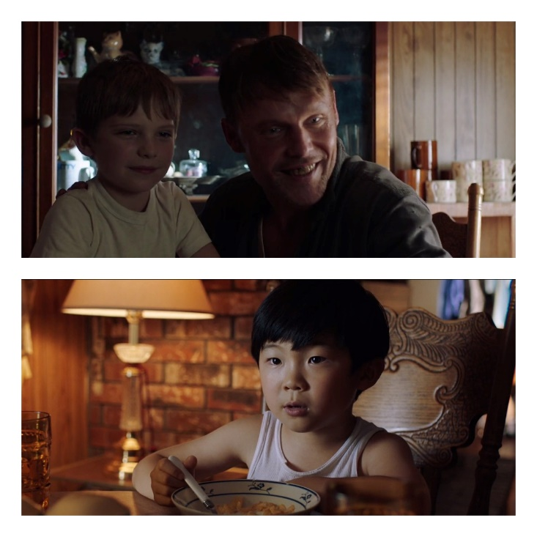
Figure 1: David, Johnny, and Johnny's dad having a conversation over breakfast.
(Chung, 2021)
Another adaptation also appears in the second generation, the scene where David is at his friend Johnny's house and talking to Johnny's father. Connotatively, this scene symbolizes the process of assimilation and identity negotiation where David tries to conform to American norms and customs while his friend's father represents a more relaxed and individualistic perspective of American culture. This interaction marks a typical process of identity negotiation and cultural adaptation in the diasporic experience.
Symbols play an important role in representing complex and dynamic cultural identities because symbols not only function as signs or symbols, but also as a medium of communication that contains deep meanings that continue to develop according to the social and cultural context of the community. According to Dewi (2022), symbols in culture are an integral part of human life that influences actions, behavior, language, and beliefs, so that human culture is full of colors and symbols that shape mindsets and social behavior (Dewi, 2022). In the context of cultural identity, symbols become an important foundation because through symbols, the values, traditions, and beliefs of a culture can be preserved and disseminated. Language, as a form of symbol, is not only a means of communication but also a medium for preserving cultural values that shape people's identities (Putri, Ayu, Ginting, Saidah, & Nasution, 2025). In addition, symbols also have a strong emotional charge and are able to cause collective resonance, thus becoming an effective means of expressing and maintaining cultural identity in the midst of social change and globalization (Seilatu, 2016).
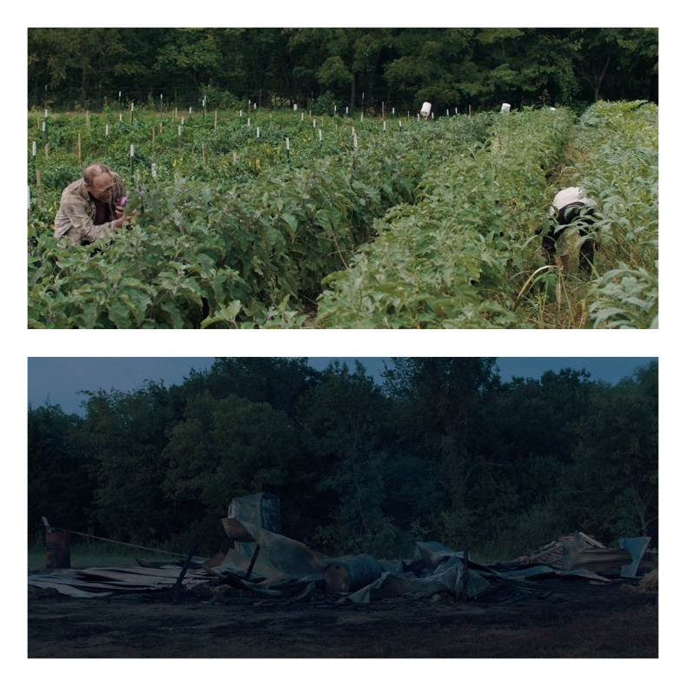
Figure 2: Jacob Farm land, and after the barn fire
(Chung, 2021)
Semiotic analysis reinforces this understanding by looking at important symbols in the movie. Jacob's farm is denotatively a source of family livelihood, but connotatively a metaphor for immigrants' struggle to take root and survive in a new land. The barn fire that occurs in the film is denotatively a physical disaster, but connotatively symbolizes the destruction of hope as well as being the starting point for the formation of family resilience and solidarity in the face of adversity. These symbols show how conflict and adaptation of cultural values do not only occur on a personal level, but also involve the Yi family's existential struggle in the context of diaspora and cultural hybridity.
The movie Minari features various cultural symbols that reflect the Yi family's cultural hybridity process as Korean immigrants in America. First, the Minari plant is denotatively a typical Korean water plant that grows in the land of Arkansas. Connotatively, this plant becomes a metaphor for the resilience of Korean culture in America, illustrating the hybridity process as a cultural adaptation that is able to develop without losing its original roots. Based on Roland Barthles' semiotic theory, the Minari plant also functions as a myth that implies hope that cultural identity can thrive through negotiation and adaptation in the space of three cultures.

Figure 3: Jacob and Monica had a Korean dinner.
(Chung, 2021)
The next symbol is food, specifically kimchi made with local American chili peppers. The denotation is that of a traditional Korean dish, but connotatively this food shows cultural creativity, combining local ingredients with traditional Korean recipes. This reflects how the Yi family not only maintains tradition, but also reworks it to suit the new environment.
Lastly, there is an interesting scene related to the use of mixed languages (Korean and English) when David justifies what his grandmother Soon-Ja says. When his grandmother praises the whining David "여기로 와요. 아이고, (come here, oh my) Pretty Boy, pretty boy “, David replies by saying:” I’m not pretty! I'm Good looking!" (Chung, 2021).
The use of mixed languages reflects David's bilingualism as a second-generation Korean-American immigrant. The Korean language used by his grandmother shows his attachment to his culture of origin, while David's response in English signifies his adaptation to American culture as well as an attempt to assert his own identity that does not fully follow Korean cultural patterns. Connotatively, this dialogue symbolizes the process of cultural hybridity and identity negotiation that takes place in the Yi family, where language becomes a medium to express complex feelings, attitudes, and cultural positions. David uses mixed language as a way of balancing the two worlds he lives in while showing his unique identity as a Korean-American diaspora.
Cultural hybridity in Minari's film includes the representation of cultural interactions that occur in the daily life of the Yi family, where Korean cultural values, customs and practices dynamically blend with American culture, forming a complex identity. It also highlights the adaptation and conflict of cultural values that arise due to the different worldviews between the two cultures, as well as how the family members respond and adjust to these challenges. This is in line with Dardner's (1995) definition of hybridity in Mi Yung Park, whereby hybridity does not merely reflect a relativistic view of culture, but functions as a form of resistance against the global structures of domination that control the lives of subordinate groups, while also opening up space for the formation of new, dynamic cultural identities. (Park, 2024). Furthermore, the film uses cultural symbols, such as the Minari plant, as a powerful metaphor to illustrate resilience and the process of cultural hybridity, where Korean culture is able to adapt and grow in the American context.

4.2 The Diasporic Experience in Minari
Minari deeply portrays the Yi family's diasporic experience, especially through their feelings of homelessness and longing for their original Korean identity. As Korean immigrants in America, the Yi family faces the reality of alienation and loss of cultural roots that they left behind in their homeland. According to Brah (1996) cited in Fikri Guven and Nimetullah Aldemir (2025), Diaspora is defined as a space of multiple belongings, where cultural identities are formed through the interaction between memory, displacement, and belonging (Güven & Aldemir, 2025). This concept is reflected in various aspects of daily life such as language, food, and religious rituals that are maintained as a form of nostalgia and efforts to maintain cultural identity in the midst of a new, unfamiliar environment.
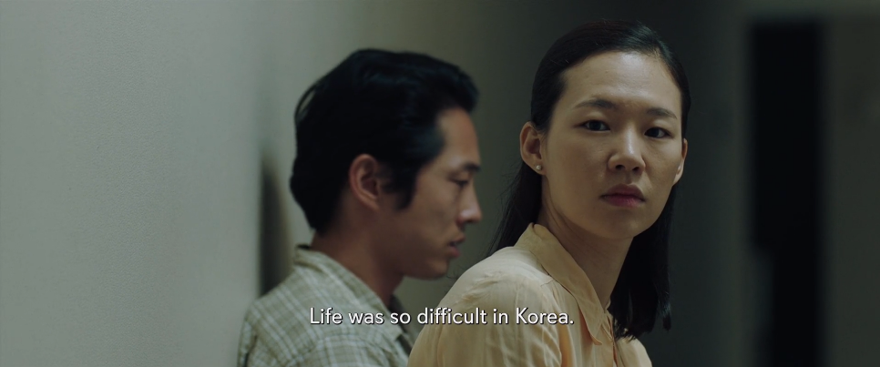
(Chung, 2021)
The sense of loss experienced by the Yi family in Minari is not only evident in their daily routines, but also in the emotional interactions between family members. One scene that powerfully illustrates their homesickness and compares the experience of living in America with memories of the past in their homeland is when Monica and Jacob discuss the difficulties they face. This scene exudes a deep sense of nostalgia as well as frustration over the challenges they have to face in the new environment. Monica often reminds Jacob about how tough life in America is, while Jacob also reminds her of their commitment at the beginning when they promised to start life in America and he still maintains an optimistic attitude for the future of their family. The following dialog where Jacob tries to convince Monica of their previous commitment is narrated in the dialog below.
Jacob: “한국에서의 삶은 어려웠다” (Life was difficult in Korea)
Jacob: “우리가 결혼할 때 뭐라고 했는지 기억나?” (Remember what we said when we got married?)
Jacob: “우리는 미국으로 이사 가서 서로를 구하겠다고 했어” (we said we’d move to America and save each other.)
(Chung, 2021)
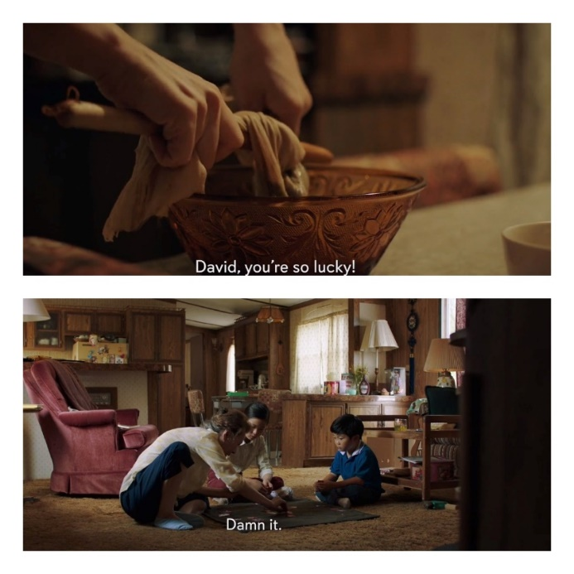
Figure 4 making traditional herbs
Soon-Ja introduces the Korean game
(Chung, 2021)
Soon-ja's grandma is an important symbol in the diaspora narrative. Soon-ja brings with her the traditions, values and memories of the past that serve as a reminder to the Yi family of their cultural roots. She introduces her grandchildren to traditional games, herbs, and Korean customs, such as planting Minari by the River. Soon-ja's presence not only strengthens the family's emotional ties to the homeland, but also serves as a bridge between the first and second generations in the process of negotiating identity. Through Soon-ja, the film emphasizes the importance of collective memory and cultural heritage as a source of strength amidst the challenges of diaspora.
The Yi family seeks to recreate “Korea” in America through various means, one of which is farming and building a small community that reflects life in the homeland. Jacob, the father, grows Korean vegetables on Arkansas land in an effort to maintain tradition and fulfil the needs of the local Korean-American community. This farming practice is not only a source of livelihood, but also a means of maintaining cultural identity and building a sense of community within the diaspora. In addition, the Yi family continues to practice religious rituals, cook traditional food, and use Korean at home, all of which are forms of resistance to the pressures of assimilation and efforts to maintain identity.
The process of diasporic community formation is depicted through the Yi family's interaction with other Korean immigrant communities in America, which becomes an important part of the dynamics of cultural hybridity. The Yi family does not live in isolation, but rather builds a social network with fellow Korean immigrants who face similar challenges in adjusting to a new environment. These interactions demonstrate the strong support and solidarity between members of the diaspora community, who help each other cope with economic, social and cultural difficulties in a foreign country.

Figure 5: church worship
(Chung, 2021)
The role of churches and social gatherings becomes a vital diasporic community center in this film. The local church serves not only as a place of worship, but also as a social gathering space where the Yi family and other Korean immigrants can maintain traditions, share experiences, and build a sense of community. According to Nagehan Uzuner (2021) he explains that sociologically, church visits help immigrant families overcome feelings of social isolation (Uzuner, 2021). Through church activities and social gatherings, they create a third space that enables the negotiation of cultural identities between Koreans and Americans, in accordance with Homi K Babha's theory of hybridity. This space becomes a place where Korean cultural values are maintained while being adapted to the American context, which strengthens community solidarity while supporting the acculturation process.
The dynamics of dual identity and the process of identity negotiation experienced by the Yi family as Korean-Americans are strongly represented in the movie. The characters face complex internal conflicts between the desire to assimilate into American culture and the need to maintain their Korean identity. This conflict is particularly evident in the younger generation, especially David and Anne, who have grown up in an American environment but remain attached to the Korean values and traditions brought to them by their parents and grandmothers.
Language becomes one of the main mediums in this identity negotiation. At home, Korean is used as a symbol of cultural preservation and emotional ties to the homeland, while outside the home, especially at school, English is predominantly used as a form of adaptation and integration with American society. As in the scene, the role of education is also very important in shaping the identity of the younger generation of the diaspora. Formal education in America opens opportunities for children to assimilate and adopt American values, but they also experience pressure to balance two different cultures, which sometimes creates an identity dilemma.
This identity negotiation does not only occur at the individual level, but also in family and community interactions, where cultural symbols such as Minari plants, traditional food, and religious rituals become a means to maintain cultural roots while adapting to the new environment. Thus, Minari presents diasporic identity as a dynamic and evolving process, where the characters try to find a balance between the two cultures that shape their lives.

5. CONCLUSION
The film Minari comprehensively represents the process of hybridity and diaspora through the story of the Yi family struggling to balance their Korean cultural identity and adaptation to American culture. Analysis shows how cultural symbols such as the Minari plant, traditional food, language, and religious rituals become a medium for negotiating identity in a third cultural space, where traditions are preserved while being adapted to the new environment. The conflict of values between the first and second generations, as well as Korean collectivism and American individualism, illustrates the complexity of the diaspora experience involving loss, longing, and hope.
This film provides deep insight into the immigrant experience and the dynamics of dual identity in the era of globalization, highlighting how diaspora communities not only face the challenges of assimilation but also actively build new hybrid and dynamic identities. Minari is socially and culturally relevant because it is able to show the reality of multiculturalism and the importance of diaspora community solidarity in maintaining cultural roots while adapting to changing times. Thus, Minari is an important work for understanding the challenges and hopes of today's diaspora communities, as well as making a significant contribution to the study of culture and intercultural communication in the era of globalization.

REFERENCES
Adidarma, N. S., & Ismail, O. A. (2022). Representasi American Dream Keluarga Asia dalam Film Minari (Analisis. Repository Telkom University, 3688.
AS, N., & Juanda. (2025). DENOTATIVE AND CONNOTATIVE MEANINGS IN THE TRUMAN SHOW: A SEMIOTICS ANALYSIS BASED ON ROLAND BARTHES'S THEORY. Mahadaya , 138.
Azzahra, A. (2021). REPRESENTATION OF IMMIGRANT’S SOCIAL IDENTITY. etheses Universitas Islam Negeri Maulana Malik Ibrahim Malang.
Baubock, R., & Faist, T. (2010). Diaspora and Transnationalism: Concept, Theorist, and Methods. Amsterdam: Amsterdam University Press.
Bhandari, N. B. (2022). Homi K. Bhabha's Third Space Theory and Cultural Identity Today: A Critical Review. Prithvi Academic Journal. doi:https://doi.org/10.3126/paj.v5i1.45049
Chung, L. I. (Director). (2021). Minari [Motion Picture].
Dewi, N. R. (2022). KONSEP SIMBOL KEBUDAYAAN: SEJARAH MANUSIA. Abrahamic Religions. doi:https://doi.org/10.22373/arj.v2i1.12070
Dogutas, A. (2024). Consequences of Immigration for Families: Structure, Culture, and. Journal of Ethnic and Cultural Studies, 192. doi:http://dx.doi.org/10.29333/ejecs/1941
Firdaus, R. M., Pottu, O. Y., Panduwal, Meilany, C., Panjaitan, V. F., & Paskalina, O. (2023). PENGARUH GLOBALISASI TERHADAP HIBRIDITAS BUDAYA KOREA PADA MASYARAKAT LOKAL THAILAND. INTELEKTIVA. Retrieved from https://www.sthf.ac.id/jurnalintelektiva.com/index.php/jurnal/article/view/926/683
Güven, F., & Aldemir, N. (2025). HYBRIDITY, IDENTITY, AND DIASPORA IN ZADIE SMITH’S WHITE TEETH. Journal og Nusantara Studies. doi:https://doi.org/10.24200/jonus.vol10iss1pp94-113
Michael, C. G. (2025). Migrant Identity and Cultural Belonging in a Globalized World. International Journal of Research Publication and Reviews. Retrieved from https://ijrpr.com/uploads/V6ISSUE5/IJRPR46245.pdf
Ojuola, T. D. (2024). Cultural hybridity and the black diaspora: Representations in contemporary African. International Journal of Science and Research Archive, 1487. doi:https://doi.org/10.30574/ijsra.2024.13.2.2308
Ortega, G. (2020). Where is home? Diaspora and hybridity in contemporary. Moderna Sprak, University of Guttenberg, 1. doi:http://dx.doi.org/10.58221/mosp.v114i4.7327
Park, Y. M. (2024). HERITAGE LANGUAGE USE AND IDENTITY CONSTRUCTION: A STUDY OF TWO KOREAN-AMERICAN BILINGUAL ADOLESCENTS. sciendo. doi:https://doi.org/10.2478/sm-2024-0001
Prasetyanti, R. F. (2025). Elements of Cultural Identity Reflecting in the First an the Second Generation in the Minari Movie (2020). Unissula Institutional Repository, 4.
Putri, B. T., Ayu, C. S., Ginting, M. A., Saidah, S., & Nasution, S. (2025). Budaya dan Bahasa : Refleksi Dinamis Identitas Masyarakat. Semantik : Jurnal Riset Ilmu Pendidikan, Bahasa dan Budaya.
Ramadhan, G. A., Poerana, A. F., & Nurkinan. (2022). REPRESENTASI MAKNA PERJUANGAN KELUARGA. NUSANTARA: Jurnal Ilmu Pengetahuan Sosial.
Rohman, N. (2025, February 05). Teori Hibriditas Budaya: Menciptakan Identitas dalam Dunia Global. Retrieved from Universitas Wira Buana: https://wirabuana.ac.id/artikel/teori-hibriditas-budaya-menciptakan-identitas-dalam-dunia-global/
Seilatu, F. (2016). OUW NEGERI SEMPE: pemaknaan simbol sempe sebagai identitas sosial di Negeri Ouw - Maluku. Repository Universitas Kristen Satya Wacana.
Solihin, O., Waluyo, E. A., & Bahriyah, E. N. (2023). REPRESENTASI KONFLIK ASIMILASI PADA KOMUNIKASI ANTAR. Komunikologi. Retrieved from http://repository.unikom.ac.id/id/eprint/70827
Uzuner, N. (2021). Lee Isaac Chung, Minari (2020): Having an Amerikorean Life. International Society of Markets and Development. doi: 10.23860/MGDR-2021-06-02-04

